Assignment 1

* Create a CloudWatch alarms for an instance.
* You can create a CloudWatch alarm that monitors CloudWatch metrics for one of your instances. CloudWatch will automatically send you a notification when the metric reaches a threshold you specify. You can create a CloudWatch alarm using the Amazon EC2 console or using the more advanced options provided by the CloudWatch console.
* To create an alarm to stop an idle instance and terminate an idle instance (Amazon EC2 console)

1. Launch an Ec2 server with default specifications.

1. Next, go to simple notification service (SNS), create a subscription for email notification, and confirm the subscription through the email ID given for alert.

1. Navigate to CloudWatch and create alarm, select metrics as Ec2 instance CPU Utilization, and set threshold greater than or equal to 5% and select the SNS and write the email alert content. Then it will send the notification to your email I.

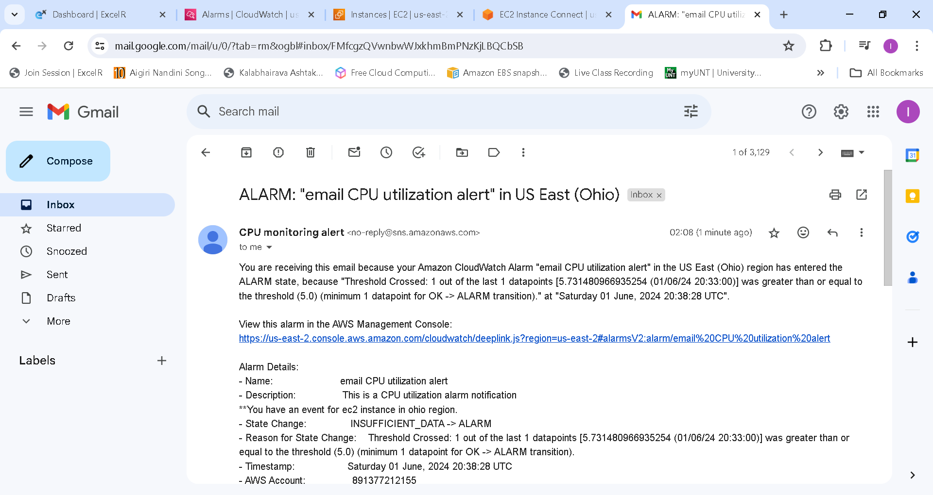

1. Create another alarm for stopping the instance and terminating the instance by setting the threshold values.

